CHAPTER 3
SYNTAX ANALYSIS AND DESIGN

3.1 INTRODUCTION

System analysis converts the problem identified in Chapter 1 into functional requirements and architectural components. HostelOS is designed as a unified, layered platform consisting of role-based user portals, a backend service layer, a central database, an AI and analytics layer, and a notification and security layer. The central design principle is that the backend is the single source of truth: every decision about authorization, gate movement and sensitive data is made on the server, while the user-facing portals only present information and collect input.
The platform integrates student accommodation, room allocation, leave, presence, gate authorization, fees, complaints, mess, maintenance, inventory, emergency response, analytics and decision support. In addition to these core areas, the design includes resident-oriented services such as Wi-Fi, gym and fitness-corner booking with subscription plans and payment deadlines, a digital fire-safety and first-aid map, a guided pre-complaint self-check, a hostel account manager for income and expenditure, and a public showcase link on the college website.

3.2 EXISTING SYSTEM

Existing hostel-management mechanisms generally fall into three categories: manual registers and spreadsheets, stand-alone hostel-management software, and hardware-based access-control systems that use RFID cards, biometric readers or routine QR scanning.
Manual registers and spreadsheets are simple to start but are difficult to search, easy to lose and cannot produce timely summaries. Stand-alone software generally digitizes forms for fees, rooms or complaints, but each function usually operates as an
isolated module with little shared data and almost no prediction or decision support. Hardware-based access control records movement but requires dedicated readers and cards at every gate, and routine QR or card scanning for every working-day entry and exit adds daily congestion without adding useful authorization.
The limitations can be summarized as follows:
The existing hostel management systems have several limitations that affect their efficiency and reliability. Although administrative activities are digitized, different modules often operate independently without proper integration. The stored data is rarely used for classification, prediction, or optimization. Complaints are handled manually without automatic categorization or priority assignment, while maintenance activities are mainly reactive, making it difficult to identify recurring problems from historical records. Meal preparation and inventory ordering are not properly forecast, which can lead to food waste and shortages. Gate control often depends on dedicated hardware or applies the same procedures to both routine and exceptional student movement, causing unnecessary delays. Emergency handling also lacks proper acknowledgement tracking and an audit trail. Furthermore, the absence of a centralized dashboard makes it difficult to monitor important information such as room occupancy, fees, complaints, student presence, maintenance, and inventory in one place. These limitations highlight the need for an integrated and intelligent hostel management system such as HostelOS.
Conventional hostel management systems face several challenges in managing daily operations effectively. Although many systems provide digital facilities for student registration, room allocation, fee collection, and complaint management, these functions are often maintained as separate modules. This lack of integration makes it difficult for administrators to obtain a complete view of hostel activities and coordinate different departments. In addition, the limited use of historical data reduces the ability of existing systems to identify patterns, predict future requirements, and support informed decision-making.
Another major limitation is the manual handling of complaints and maintenance requests. Complaints may not be automatically categorized according to their type or urgency, which can delay the resolution of important issues. Similarly, maintenance is usually performed after a problem occurs rather than being predicted in advance. Without analyzing previous maintenance records, recurring faults may remain unnoticed, resulting in repeated repairs, increased costs, and inconvenience to residents.

3.3 PROPOSED SYSTEM

HostelOS proposes a unified intelligent platform that combines hostel administration, safety workflows and an AI-assisted decision-support layer. All modules share one database and one role-based access model, so that data entered in one module (for example, a complaint) can be used by another (for example, predictive maintenance and risk analysis).
A deliberate design decision concerns the gate. NFC/RFID has been removed from the current design. Normal working-day movement to and from college does not require any QR. A temporary, server-verified QR token is issued only when special authorization is required, such as a late return, a holiday outing, or a medical or personal visit. The proposed flow of control is:
Notification
Database
AI/Analytic service
Backend APIS

User portal

For the QR feature the backend performs all validation; a QR image by itself is never trusted, and it carries only a secure token reference rather than student data.

3.4 FUNCTIONALITIES

The functionality of HostelOS focuses on simplifying and improving hostel management through an integrated digital platform. It provides facilities for student registration, profile management, room and bed allocation, attendance tracking, leave requests, and visitor management. Students can use the system to submit complaints, request maintenance services, book amenities, and receive important updates. The service module helps staff manage mess operations, inventory, and maintenance activities efficiently, while the finance module supports hostel fee management, payment tracking, income and expenditure records, and payment reminders.
HostelOS also incorporates intelligent features to improve decision-making and safety. AI-based complaint classification helps categorize complaints and assign priorities, while predictive maintenance identifies possible maintenance needs using historical records. Meal and inventory forecasting helps estimate demand and reduce food waste. The system includes emergency SOS alerts, fire safety information, and QR-code verification for exceptional student movement. Role-based access control ensures that students, wardens, security staff, and administrators can access the appropriate features. Overall, HostelOS reduces paperwork, improves communication, supports better resource utilization, and provides a more secure, organized, and efficient hostel management experience. The platform is designed to be user-friendly and scalable, allowing additional features to be introduced as hostel requirements grow. These functionalities make HostelOS a practical solution for improving operational efficiency, student satisfaction, and overall hostel management.

3.5 NON-FUNCTIONAL REQUIREMENTS

Usability: Each role should see only the screens and actions relevant to it. Routine tasks such as applying for leave, raising a complaint or booking a slot should require few steps, and the interface should be usable on both a desktop browser and a smartphone.
Reliability: The system should tolerate temporary network problems. A controlled fallback and synchronization approach is needed for gate verification so that movement events are not lost when connectivity is interrupted, and so that offline-recorded events can be reconciled with the server afterwards.
Security: Access to every operation must be authenticated and authorized. Passwords must be stored using secure hashing, API endpoints must enforce authorization, QR tokens must be unique, short-lived and verified on the server, and input must be validated.
Privacy: Role-based access limits who can see personal, medical, financial and movement information. Gate events indicate movement and presence state; they are not continuous location tracking. Audit logs record access to sensitive data.
Performance and Maintainability: Common operations such as dashboards, complaint registration and QR verification should respond quickly. The modular design should allow individual modules, in particular the AI models, to be improved or replaced without changing the rest of the system.

3.6 SYSTEM ARCHITECTURE

System architecture is the overall structure of a system that explains how its different components are organized and connected to work together. In the HostelOS project, the system architecture consists of five main layers: the presentation layer, application or service layer, intelligence layer, data layer, and notification and security layer. The presentation layer allows students and staff to access the system through a web portal, mobile app, or college website. The application layer manages authentication, room allocation, leave requests, complaints, mess, inventory, payments, and finance. The intelligence layer uses AI and analytics for complaint classification, predictive maintenance, meal and inventory forecasting, room allocation, and risk analysis. The data layer stores all essential information in a central database, including student details, rooms, finances, complaints, inventory, and presence records. Finally, the notification and security layer manages emergency SOS alerts, fire safety notifications, QR verification, push notifications, and emails. These layers work together to provide a unified, intelligent, secure, and efficient hostel management system.
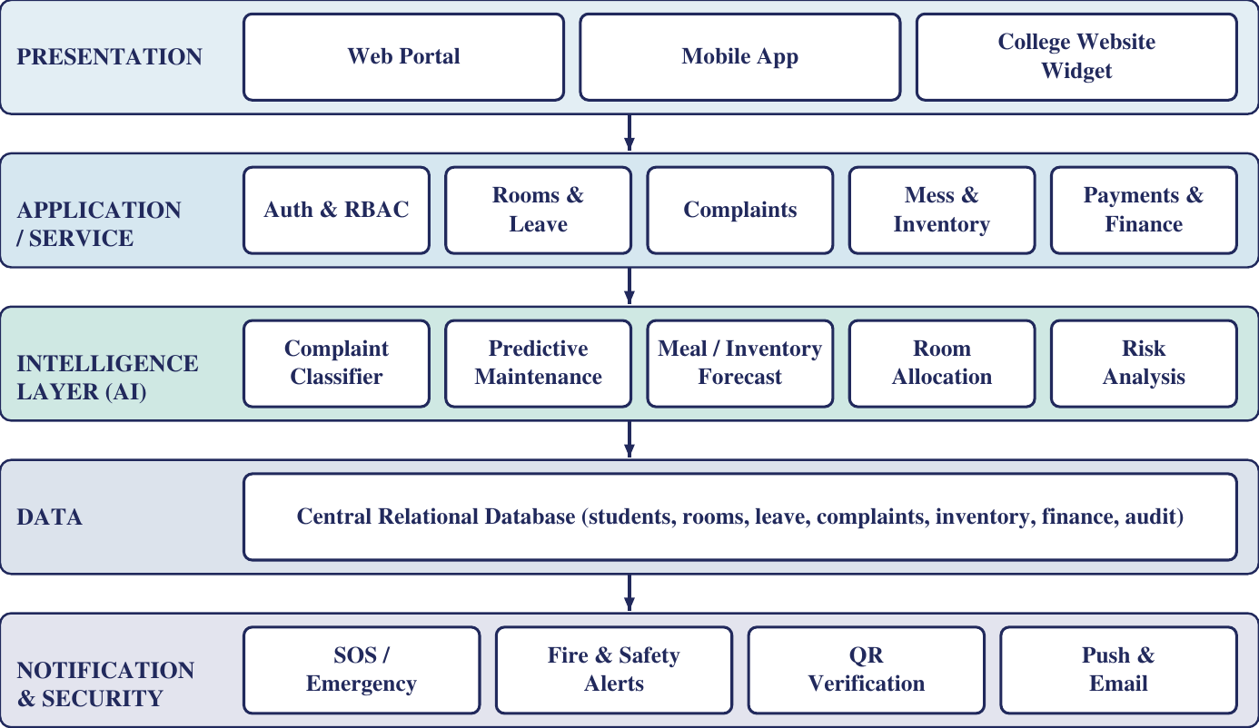
Figure 3.1: High-Level HostelOS System Architecture
The backend is the source of truth for every layer. Because all QR validation is performed on the server, the presentation layer cannot bypass authorization.

3.7 USER ROLES AND ACCESS MODEL
HostelOS defines seven logical roles, and each role can access only the information and operations needed for its duties. Students manage their own profile and room details, raise leave and exceptional-movement requests, register complaints, view fees, make bookings and trigger SOS alerts. Parents or guardians see only limited information about the associated student, such as leave status and notifications. Wardens approve leave and exceptional movement, handle complaints and incidents, and view presence and block-level data. Security personnel scan and verify QR tokens at the gate, view the movement results and acknowledge incidents. Administrators manage users, rooms, fees and finance, and have access to analytics, risk indicators and audit logs. Mess staff handle meal plans, bookings, preparation figures, waste records and kitchen inventory, while maintenance staff receive classified complaints and maintenance tasks and update their status. This role-based separation protects sensitive data, limits the effect of misuse or error, and keeps responsibilities clearly divided across the platform.
Role | Principal access and responsibilities
Student | Own profile and room, leave and exceptional-movement requests, complaints, fees, bookings, SOS.
Parent / Guardian | Limited information about the associated student, such as leave status and notifications.
Warden | Approves leave and exceptional movement, handles complaints and incidents, views presence and block-level data.
Security | Scans and verifies QR tokens at the gate, views movement results and acknowledges incidents.
Administrator | Manages users, rooms, fees and finance; views analytics, risk indicators and audit logs.
Mess staff | Manages meal plans, bookings, preparation figures, waste records and kitchen inventory.
Maintenance staff | Receives classified complaints and maintenance tasks and updates their status.
Table 3.1: Roles and Access Scope

Authentication: Each user signs in with credentials that are verified against securely hashed passwords. A successful sign-in produces a session or token that identifies the user and the role.
Authorization: Every API request is checked against the role before data is returned or an action is performed. Authorization is applied on the server regardless of what the user interface displays.

3.8 GATE AUTHORIZATION MODEL

Normal Movement: Normal working-day college movement during permitted hours does not require a QR. Hostel presence is maintained through the normal hostel presence process and the approved leave state, and the system shows states such as IN, OUT or ON LEAVE. Academic college attendance is a separate matter and is not handled by this QR feature.

Exceptional Movement: A QR token is required only when special authorization is needed, for example when a student returns after the permitted hostel time, leaves on a holiday or closed day, makes a medical visit, or goes on a personal outing. This keeps the gate free of routine congestion while ensuring that unusual movement is explicitly authorized and traceable.

QR Token Design: The QR code contains only a secure token or reference. The details of the permission are held on the server. A token is therefore a pointer, not a document, and its value is limited if it is copied. A conceptual token record is:
T = {tokenID, studentID, requestID, purpose, validFrom, expiry, status}
At scan time the backend accepts the movement only if the token exists, has not expired, has not been used, belongs to the associated student, matches an approved permission and is compatible with the student's current presence state:
Valid (T) = exists(T) AND now < expiry AND status = UNUSED AND student matches AND permission approved AND state compatible

3.9 USER WORKFLOW EXAMPLES

Holiday Outing: The student first submits an exceptional movement request through the HostelOS portal. The warden or an authorized staff member reviews the request and approves it. Once approved, the backend generates a unique, temporary QR token and displays it to the student. At the hostel gate, the student presents the QR code, which is scanned by the security officer. The backend verifies the token's validity, expiry time, student association, and permission before allowing the movement.
After successful verification, the movement is recorded, the student's presence status is updated to OUT, and the activity is stored in the audit log. When the student returns, additional authorization is required if the return occurs after the permitted time; otherwise, normal presence rules apply. Any invalid, expired, or previously used QR token is rejected and recorded in the system log. This workflow improves hostel security, maintains accurate student movement records, and ensures that exceptional outings are properly authorized and monitored.

Complaint with Pre-Complaint Self-Check: The student starts a complaint through the HostelOS system and selects the appropriate category. Before the complaint is finally registered, the system provides a guided self-check to identify simple problems, such as a closed water valve or a tripped miniature circuit breaker (MCB). If the student resolves the issue through this self-check, a formal complaint is not registered, helping reduce unnecessary complaints.
If the problem remains unresolved, the system registers the complaint, automatically classifies it, and forwards it to the maintenance staff according to its priority. This helps ensure that urgent issues receive appropriate attention and are handled efficiently. The complaint details and resolution status are stored in the database for future reference. These records can later be used for predictive maintenance and risk analysis, helping administrators identify recurring problems and improve hostel maintenance services.
Room Allocation Workflow: When a new student registers in HostelOS, the administrator enters or verifies the student's details and room requirements. The system checks room availability, capacity, and allocation constraints before suggesting a suitable room or bed. Once the allocation is approved, the student's room details are stored in the database and updated in the administrative dashboard. This process reduces manual work, avoids duplicate allocations, and improves room management.
Emergency SOS Workflow: When a student faces an emergency, they can activate the SOS feature through the HostelOS platform. The system records the emergency request and sends an alert to the authorized hostel staff. The responsible staff member acknowledges the alert and takes the necessary action. The system tracks the acknowledgement and records the response details for future reference. This workflow helps improve emergency coordination, accountability, and student safety.
Predictive Maintenance Workflow: HostelOS stores historical maintenance records, including previous complaints, repair activities, and recurring faults. The system analyses these records to identify patterns that may indicate future maintenance requirements. When a potential issue is identified, the system can alert administrators or maintenance staff to inspect the affected facility. This workflow supports early problem detection, reduces repeated faults, and helps minimize maintenance costs.
These examples show that the platform handles both safety-related workflows and everyday service workflows in a single role-controlled system.

3.10 SECURITY AND PRIVACY DESIGN

Security is integrated into the architecture rather than treated as a separate add-on.
Authentication and Password Protection: Users are authenticated before any protected operation, and passwords are stored only as secure hashes.
Role-Based Access Control: RBAC separates permissions according to role. A student, warden, security officer and administrator do not have identical access to system resources.
Temporary, Server-Verified QR Tokens: QR tokens are unique and short-lived, and are verified by the backend. A token that is expired, already used or not associated with the scanning context is rejected.
Input Validation and API Authorization: All inputs are validated, and every API endpoint checks the caller's role before returning data or applying a change.
Audit Logging: Sensitive operations, including approvals, gate scans, SOS handling and access to protected records, are recorded with the actor, action, resource and timestamp. Audit records support accountability and investigation.
Controlled CCTV: CCTV is treated as an optional, controlled security component with defined access, retention and audit policies. It complements, rather than replaces, the gate and incident workflow.
Privacy and Access Control: The system ensures that students, wardens, security staff, and administrators can access only the information relevant to their roles, helping prevent unauthorized access and maintain privacy.
Data Backup and Recovery: Regular backups should be maintained to protect important records and support recovery after accidental deletion or system failure.
Data Encryption: Sensitive student information and financial records are encrypted both in transit and at rest to prevent unauthorized access. All communication between the web portal, mobile app and backend takes place over secure HTTPS (TLS) connections, so data cannot be read or altered while it travels across the network. Stored data, including personal details, payment records and credentials, is protected through encrypted database storage, and passwords are saved only as salted hashes rather than in plain text. Together with JWT-based authentication and role-based access control, this ensures that even if storage or network traffic is intercepted, the information remains unreadable to unauthorized parties.

3.11 UML-ORIENTED SYSTEM VIEWS

3.11.1 Use Case View
The principal actors are the student, parent or guardian, warden, security, administrator, and mess and maintenance staff. The student initiates leave, movement, complaint, booking and SOS requests. The warden and administrator approve and oversee. Security verifies QR tokens at the gate.

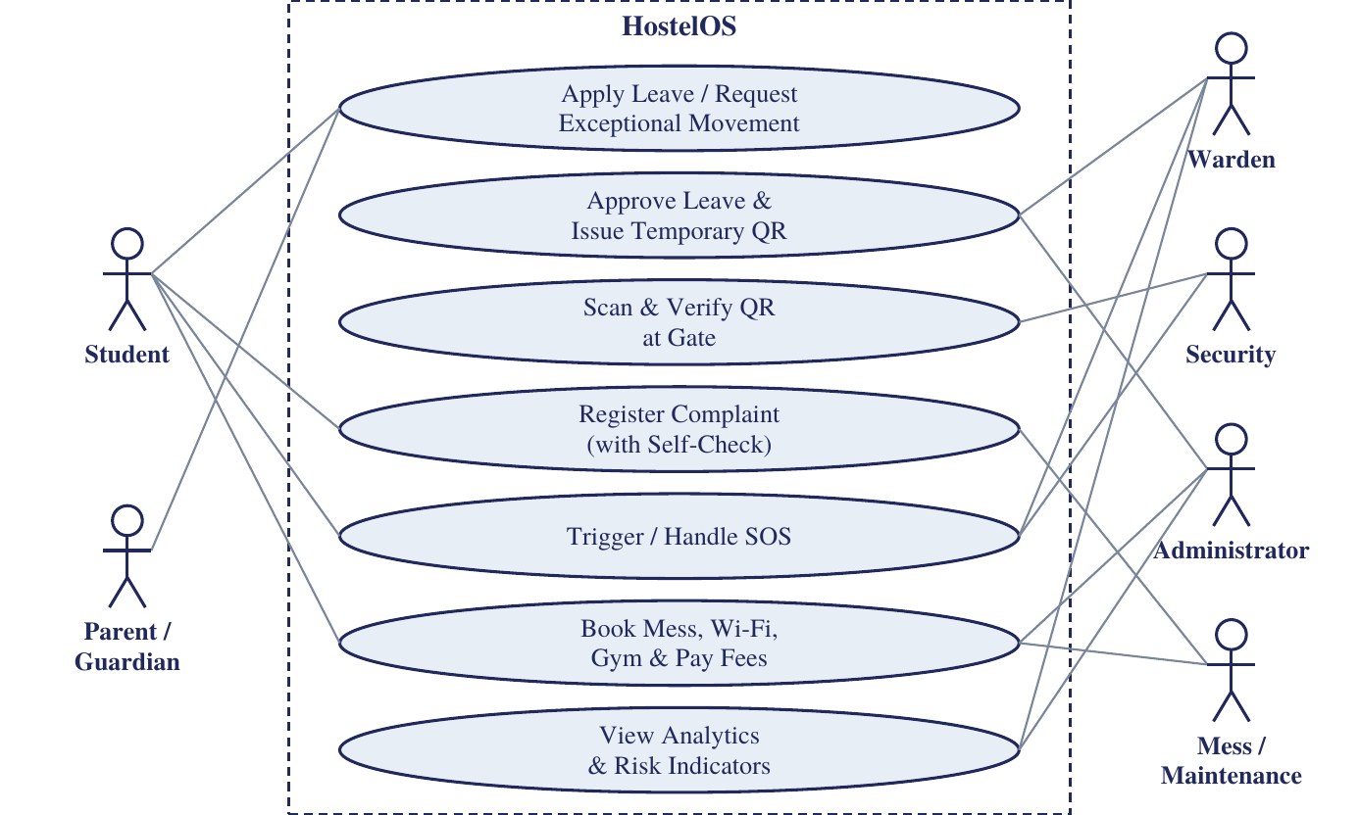
Figure 3.2: Simplified Use Case View
The use case diagram of HostelOS represents the interaction between different users and the hostel management system. It shows the main activities performed by students, parents or guardians, wardens, security staff, administrators, and mess or maintenance staff. The rectangle represents the system boundary of HostelOS, while the oval shapes represent the functions or services provided by the system. The lines connecting the users to the ovals show which functions they interact with.
Figure 3.2 is a simplified UML use case diagram. It shows what each type of user can do in HostelOS. The dashed rectangle is the system boundary, each oval inside it is a function the system provides, and each line connects an actor (a user role) to a function it takes part in. Students are on the left, along with parents or guardians. Wardens, security, administrators and mess or maintenance staff are on the right.
The student connects to the functions they use directly: applying for leave or requesting exceptional movement, registering a complaint with the guided self-check, triggering an SOS, and booking mess, Wi-Fi or gym slots and paying fees. The parent or guardian connects only to the leave and movement function, which reflects their limited, view-oriented access. On the other side, the warden approves leave and issues the temporary QR token, and also takes part in handling SOS incidents. Security personnel scan and verify the QR at the gate and acknowledge SOS incidents. The administrator is linked to approvals, bookings and fees, and analytics with risk indicators. Mess and maintenance staff are linked to the complaint function, where they receive classified complaints and tasks, and to the booking function, where they manage meal plans and bookings.
The diagram matches the role-based access model in Section 3.7, because each actor reaches only the functions needed for its duties. It also shows the exceptional-movement flow across three roles: the student requests, the warden approves and issues the token, and security verifies it.

3.11.2 Sequence View

The sequence for exceptional movement begins with a student's request and ends with a server-side record and audit entry:

Scan
Token
Approval
Request

Audit log
Movement Record
Server verification

The figure shows the exceptional-movement sequence as seven connected steps, read left to right across the first row and then continuing on the second row. The process starts with a Request raised by the student for a late return, holiday outing, or medical or personal visit. The warden or authorized staff gives Approval, after which the backend generates a temporary Token in the form of a QR code. At the gate, security personnel perform the Scan with a device camera, and the scanned data is sent to the backend for Server Verification, where the token is checked for validity.
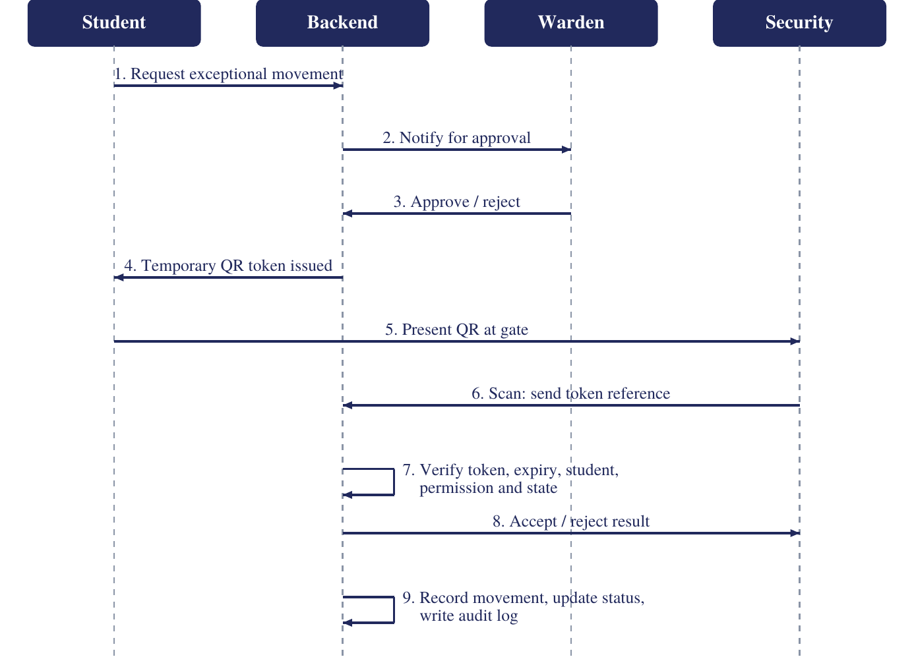
Figure 3.3: Sequence for Exceptional-Movement QR Authorization
Figure 3.3 is a UML-style sequence diagram showing how an exceptional-movement QR authorization is exchanged between four participants: the Student, the Backend, the Warden and Security. Each vertical dashed line is a participant's lifeline, and the numbered horizontal arrows show the messages in time order from top to bottom.
The process begins when the student sends a request for exceptional movement to the backend (step 1). The backend notifies the warden for approval (step 2), and the warden approves or rejects the request (step 3). On approval, the backend issues a temporary QR token to the student (step 4). When the student reaches the gate, they present the QR code to the security personnel (step 5), who scan it and send the token reference to the backend (step 6). The backend then verifies the token, its expiry, the student, the permission and the current state (step 7), and returns an accept or reject result to security (step 8). Finally, the backend records the movement, updates the student's status and writes an audit log entry (step 9).
Steps 7 and 9 are drawn as self-pointing arrows because the backend performs them internally, with no other participant involved. The diagram also shows that the backend is the central authority. The student, warden and security staff never communicate directly except for step 5, which is the physical presentation of the QR code at the gate, and every decision and record is made server-side. This keeps the process secure and traceable, because a token that is invalid, expired or already used is rejected and logged.

3.12 DATA ARCHITECTURE

The data model is relational. Its principal entities are the Student, Room and Bed, Leave Request, QR Token, Movement Record, Complaint, SOS Incident, Payment and Booking, together with supporting entities for maintenance history, meals, inventory, financial transactions, fire-safety assets and the audit log.
A student is associated with a room and bed and can create leave requests, complaints, SOS incidents, payments and bookings. An approved leave or exceptional-movement request can result in a QR token. A scanned token creates a movement record. Audit events are written for sensitive operations and refer to the acting user and the affected resource, so they are not drawn as a separate relationship in the figure.
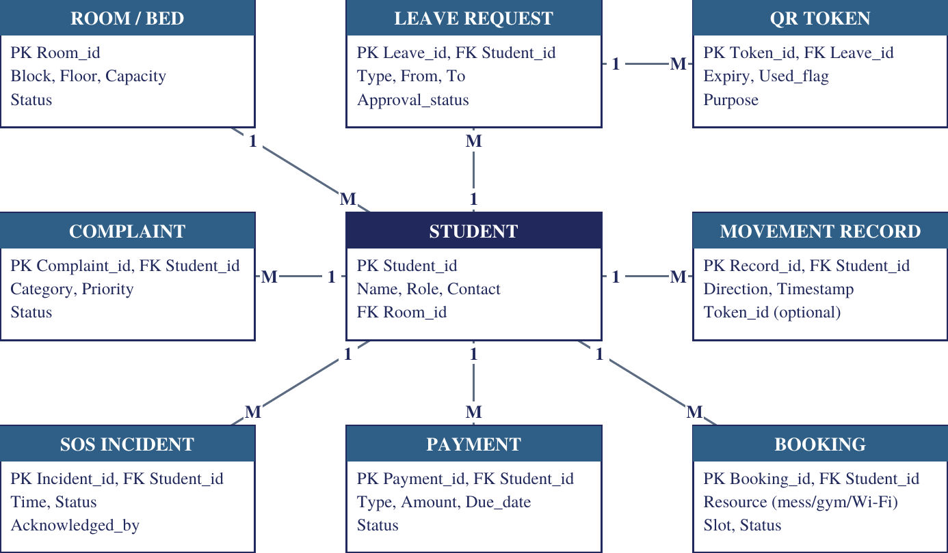
Figure 3.4: Conceptual Entity-Relationship Diagram of HostelOS
Figure 3.4 shows the conceptual Entity-Relationship (ER) diagram of HostelOS, with the STUDENT entity at the centre as the main link between the modules. Student records hold the primary key Student_id along with name, role, contact details and a foreign key Room_id. A room or bed can be assigned to many students (1:M), and each student can raise many complaints, submit many leave requests, make many payments and bookings, and be associated with many SOS incidents and movement records, so all of these entities carry Student_id as a foreign key. The exceptional-movement workflow is modelled through the LEAVE REQUEST, QR TOKEN and MOVEMENT RECORD entities. One approved leave request can generate multiple QR tokens (1:M), each with an expiry time, a used flag and a purpose, so that expired or reused tokens can be rejected. A movement record stores the direction and timestamp of each entry or exit and optionally links to the Token_id used, because routine movement needs no token. The COMPLAINT entity stores the category, priority and status that support AI-based classification and routing, SOS INCIDENT records the time, status and the person who acknowledged it for audit purposes, PAYMENT tracks type, amount, due date and status, and BOOKING covers mess, gym and Wi-Fi resource slots. Together, the diagram shows how the platform keeps all student-related operations in one structured database with clear relationships.

3.13 DATA ELEMENTS

Entity | Principal attributes | Purpose
Student | Student_id, Name, Role, Contact, Room_id | Identifies the resident and links all records.
Room / Bed | Room_id, Block, Floor, Capacity, Status | Accommodation and allocation.
Leave Request | Leave_id, Student_id, Type, From, To, Approval_status | Digital leave and authorization.
QR Token | Token_id, Leave_id, Expiry, Used_flag, Purpose | Temporary exceptional-movement authorization.
Movement Record | Record_id, Student_id, Direction, Timestamp | Gate and presence history.
Complaint | Complaint_id, Student_id, Category, Priority, Status | Complaint handling and classification.
Maintenance History | Task_id, Asset/Area, Fault type, Date, Resolution | Input to predictive maintenance.
Meal / Consumption | Meal_id, Date, Booked, Prepared, Consumed, Wasted | Meal forecasting and waste analysis.
Inventory | Item_id, Stock, Usage, Reorder_level | Inventory forecasting.
SOS Incident | Incident_id, Student_id, Time, Status, Acknowledged_by | Emergency response and audit trail.
Payment / Subscription | Payment_id, Student_id, Type, Amount, Due_date, Status | Fees, subscriptions and deadlines.
Booking | Booking_id, Student_id, Resource, Slot, Status | Mess, gym, fitness-corner and Wi-Fi booking.
Transaction | Txn_id, Category, Income/Expense, Amount, Date | Hostel account manager.
Safety Asset | Asset_id, Type, Block/Floor, Location, Last_check | Fire alarm, extinguisher and first-aid map.
Audit Log | Log_id, Actor_id, Action, Resource, Timestamp | Accountability and investigation.
Table 3.2: Major Data Entities and Attributes

3.14 THREAT CONSIDERATIONS

Because HostelOS handles personal records, finances, movement and emergency events, several threat categories must be considered.
QR Misuse: A student could try to share, copy or reuse a QR. Tokens are unique, short-lived and server-verified, are bound to a student and a permission, and are marked used after acceptance. The server rejects and logs invalid, expired or reused tokens.
Unauthorized Data Access: Without authorization checks, a user could view another person's records. RBAC and API authorization limit data to the role that needs it, and audit logs record access to sensitive information.
Credential Compromise: Secure password hashing and authentication reduce the impact of a database leak or password guessing.
Tampering with Client Input: Because users can modify what their browser sends, the server validates all inputs and does not trust any value that arrives from the client, including a QR image.
Network Failure at the Gate: If connectivity fails, a controlled fallback and later synchronization procedure is used so that movements are not lost and are reconciled with server records.
Misleading AI Output: AI classifications and predictions can be wrong. Outputs are evaluated with standard metrics and human correction is allowed, so that automated suggestions assist staff rather than replace their judgement.
Denial-of-Service Attacks: Attackers may overload the HostelOS server with excessive requests, making the system unavailable to students and staff. Rate limiting and traffic monitoring can help maintain service availability.
Notification Spoofing: Fake messages may be sent to students pretending to be official hostel notifications. Notifications should be delivered through authenticated channels and verified system accounts.
Data Loss or Corruption: Hardware failure, software errors, or accidental deletion may damage important records. Regular backups, recovery testing, and transaction controls help maintain data integrity.
Malicious File Uploads: Users may upload harmful files through complaint or document-submission features. File-type validation, size restrictions, and malware scanning can reduce this risk.

CHAPTER 4
IMPLEMENTATION

4.1 INTRODUCTION

This chapter defines the implementation requirements and the major modules of HostelOS. The implementation combines a web and mobile-friendly front end, a backend API, a relational database, an AI and machine-learning environment, authentication with RBAC, QR generation and validation, dashboards, notifications and logging.
The project format specifies software requirements, hardware requirements and system modules as the principal parts of the implementation chapter. The technology names given here are the proposed choices for the project; the final names should match the stack that the team actually implements. The chapter describes the planned design of each module. The status of the actual implementation is reported separately and should reflect the team's real progress, and no module is described here as completed unless it has been built.

4.2 SOFTWARE REQUIREMENTS

The software architecture is divided into four computational layers.

Frontend: The user interface is delivered as a web application for administrators, wardens and staff, and as a mobile-friendly interface or mobile application for students and security personnel. The security interface needs access to the device camera to scan QR codes. A React-based web frontend and a Flutter or React Native mobile application are proposed.

Backend API: The backend exposes a REST-style HTTPS API that implements business logic for authentication, RBAC, rooms, leave, gate authorization, complaints, mess, inventory, payments and notifications. FastAPI (Python) or Express (Node.js) is proposed. Python is attractive because the AI components can then share a codebase

with the API. The backend validates each request and enforces authorization before any data is returned.
Database and Persistence: A relational database, for which PostgreSQL is proposed, stores users, rooms, leave requests, QR tokens, movement records, complaints, maintenance history, meals, inventory, payments, transactions, safety assets and audit events. A relational model suits the many one-to-many relationships between a student and that student's records.

AI and Machine-Learning Environment: The intelligence layer uses Python libraries such as scikit-learn for text classification and risk prediction, and time-series or regression methods (for example Prophet or standard regression) for meal and inventory forecasting. Models are trained on the hostel's historical data and are evaluated with the metrics described in Section 4.4.3.

Development, Testing and Evaluation Tools: Git is used for version control, Docker for reproducible deployment, and an agentic development environment (Google Antigravity) as an aid during development. Automated tests should cover authorization correctness, QR acceptance and rejection, and the accuracy of AI components, and the evaluation layer should record timestamps so that response times can be measured.
Data and Security Requirements: The system must store student information, room details, complaints, financial records, inventory information, and movement logs accurately. It should use authentication, role-based access control, secure communication, regular backups, and proper data recovery mechanisms to protect information.
User Requirements: The system should provide different access permissions for students, wardens, administrators, and security staff. Each user should be able to access only the features and information relevant to their role. The interface should be simple and easy to understand.
These requirements work together with the software requirements to make HostelOS a practical and intelligent hostel management platform. Together, these software components support the efficient, secure, and intelligent operation of the HostelOS platform.

Layer | Proposed technology | Purpose
Frontend (web) | React | Role-based portals and dashboards
Mobile | Flutter / React Native | Student and security mobile access, QR display and scanning
Backend / API | FastAPI (Python) or Express (Node.js) | Business logic, REST API, authorization
Database | PostgreSQL | Persistent relational storage
AI / ML | scikit-learn, Prophet / regression | Classification, forecasting and risk prediction
Authentication | JWT with RBAC middleware; hashed passwords | Identity and access control
QR | QR generation library with server-side token validation | Temporary exceptional-movement passes
Notifications | Push and e-mail services | Alerts, reminders and status updates
Dev and hosting | Git, Docker, cloud VM or college server | Version control and deployment
Table 4.1: Proposed Software Requirements of HostelOS

4.3 HARDWARE REQUIREMENTS

Because NFC/RFID has been removed from the design, HostelOS needs no specialized gate hardware. Its hardware requirements are those of a conventional web service together with ordinary user devices.
Component | Specification | Purpose
Application server | 2 to 4 vCPU, 4 to 8 GB RAM, Linux (Ubuntu or equivalent) | Runs the backend API and AI services
Database server | Same or dedicated instance with persistent SSD storage | Stores all hostel data and audit records
Smartphones | Android or iOS with a camera | Student access; QR display; security QR scanning
PCs / laptops | Standard browser-capable computers | Administrator, warden and staff dashboards
Network | Hostel LAN, router or switch, Internet connection | Connectivity between users and the server
Wi-Fi access points | Existing hostel Wi-Fi infrastructure | Supports the Wi-Fi amenity and subscription feature
CCTV (optional) | Existing or new IP cameras | Optional controlled security component
Table 4.2: Hardware Requirements of HostelOS

Application Server: The application server hosts the API and the AI services. The stated size is sufficient for a college-scale deployment or a demonstration, and can be enlarged if the number of users grows.

Database Server and Storage: The database needs reliable persistent storage and regular backups because it holds the audit trail and financial records. Using solid-state storage improves response times for dashboards and queries.

Client Devices: Students and security staff use smartphones, whose cameras are sufficient for scanning QR codes, so no dedicated scanner is needed. Administrators and wardens use ordinary computers.

Network and Peripheral Equipment: Standard hostel networking carries all traffic. Wi-Fi access points support the Wi-Fi amenity. CCTV, if adopted, is an optional peripheral subject to access, retention and audit policies.

Absence of Dedicated Gate Hardware: Removing NFC/RFID eliminates card readers, cards and the associated maintenance, and reduces cost and operational complexity. The gate depends only on a smartphone camera and the backend.

4.4 SYSTEM MODULES

HostelOS is divided into four principal modules for implementation:
- Core Administration, Identity and Movement Authorization Module.
- Safety, Emergency and Gate Verification Module.
- Intelligence and Analytics Module.
- Resident Services and Finance Module.
The modules share one database and one authorization layer. Each can be developed and demonstrated independently, and they are integrated through the backend API.

4.4.1 Core Administration, Identity and Movement Authorization Module

This module forms the administrative foundation of HostelOS. It manages who the users are, where they live and whether they are permitted to move.
The module also aims to recommend suitable room allocations in an explainable manner, allowing administrators to understand the reasons behind allocation decisions. It manages student leave requests and approval processes while maintaining accurate hostel presence statuses, such as IN, OUT, and ON LEAVE. These features help administrators monitor student accommodation and movement efficiently.
Another important objective is to manage exceptional movement requests by receiving and approving requests and generating temporary QR tokens for authorized students. These tokens can be verified at the hostel gate to ensure that student movement is properly authorized. Overall, the module aims to improve administrative efficiency, strengthen hostel security, maintain accurate records, and provide reliable control over student identity, accommodation, and movement

Authentication and RBAC: A user signs in, and the backend issues a token that identifies the user and the role. Each protected endpoint checks the role before it proceeds. Passwords are stored as secure hashes.
Room Allocation: Room allocation uses room capacity, availability and permitted constraints or preferences. A constraint-based optimization or an explainable scoring method ranks feasible assignments. A feasible assignment must satisfy availability and capacity, and feasible rooms can then be ranked by a weighted score:

Score(s, r) = w₁f₁(s, r) + w₂f₂(s, r) + ... + w_{n}f_{n}(s, r)

where f_{i} measures how well room r satisfies the i-th permitted criterion for student s and w_{i} is its weight. Because the score is a sum of named terms, the system can state which criteria produced a recommendation, which supports human review and correction.

Leave and Presence: A student submits a leave request that is approved or rejected by authorized staff. Presence is maintained as a state determined by recorded events and approved leave:
IN ↔ OUT ↔ ON LEAVE
Normal working-day movement does not change the process, and no QR is requested for it. Academic attendance is separate from hostel presence.
Exceptional-Movement Request and Token Generation: When a student needs special authorization, such as a late return, a holiday outing or a medical or personal visit, the student submits a request. After authorized staff approve it, the backend generates a unique temporary token with an expiry and associates it with the student and the permission. The QR encodes only the token reference.
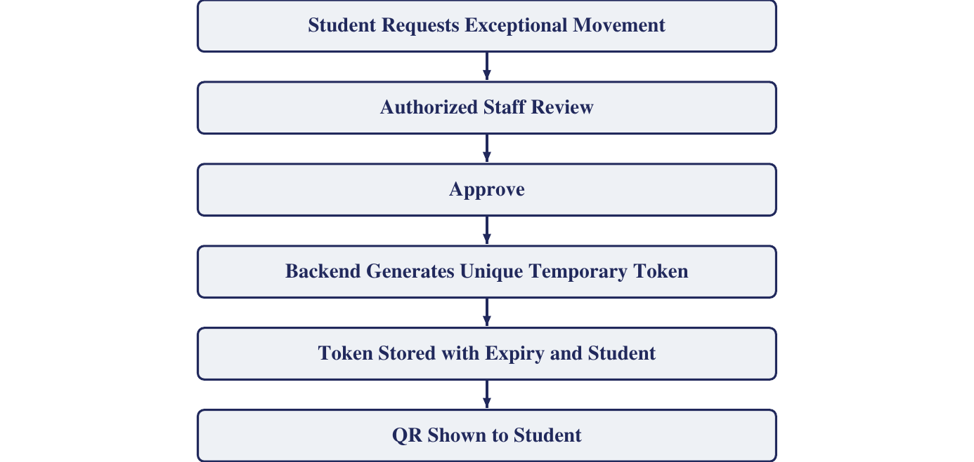
Figure 4.1: Exceptional-Movement Request and Token Generation

4.4.2 Safety, Emergency and Gate Verification Module

This module protects residents and ensures that gate decisions are made on the server. It also covers the safety-related resident features. The module maintains a digital map of important safety facilities, including fire alarms, fire extinguishers, and first-aid stations, allowing residents and authorized staff to locate them when needed. It also provides a guided self-check feature before the final registration of complaints, helping students identify and resolve simple problems. In addition, the module maintains an audit trail of security-related events to support accountability and future investigation.

Server-Side QR Verification: When security scans a QR, the application sends the token reference to the backend, which checks every condition and returns an accept or reject result. A QR image alone is never trusted. The backend accepts a scan only when the following all hold:
- the token exists and has not been tampered with;
- the token has not expired and has not already been used;
- the token belongs to the associated student;
- the underlying permission is approved; andthe movement is consistent with the student's current presence state.
- A valid scan records the movement, updates the presence state and marks the token used. An invalid, expired or reused token is rejected and logged. If the network fails, a controlled fallback and later synchronization procedure is applied.
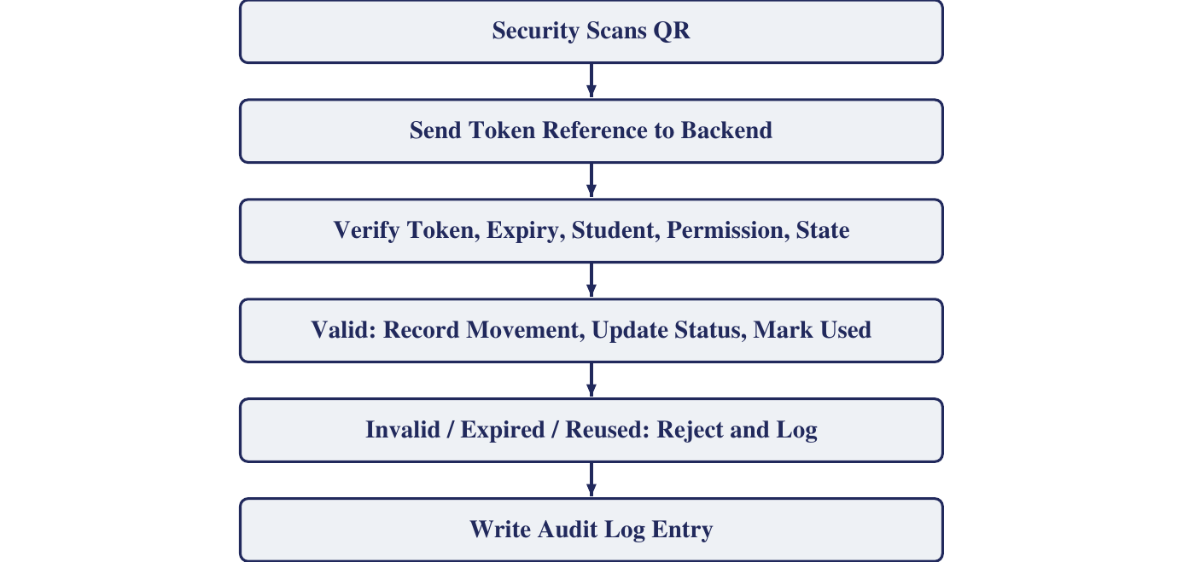
Figure 4.2: Server-Side QR Verification Workflow

Emergency and SOS: A student can trigger an SOS request. The backend records the incident, alerts authorized personnel, tracks acknowledgement and response status, and maintains an audit trail. An incident can be modelled with the states:

Responding
Acknowledged
Resolved
Alerted
Triggered

Fire-Safety and First-Aid Map: The digital blueprint records the location of fire alarms, extinguishers and first-aid stations by block and floor, together with the date of the last check. Staff can see which equipment is due for inspection, and in an emergency the map shows where equipment is located. Fire and safety alerts are sent through the notification layer.

Pre-Complaint Self-Check: Before a complaint is finally registered, the student is guided through a short checklist appropriate to the category, for example whether a water valve is closed or whether an MCB has tripped. If the check resolves the issue the complaint is not registered; otherwise it proceeds to registration and to the classification described in Section 4.4.3. This reduces avoidable complaints and saves maintenance effort.

4.4.3 Intelligence and Analytics Module

This module is the feature that most distinguishes HostelOS from conventional hostel software. It converts stored operational data into classification, prediction and decision support. The methods below are proposed; the exact algorithms are to be finalized after the available data has been examined.
Another important objective is to forecast meal demand and analyse food waste using available hostel data. This helps administrators plan food preparation more effectively, reduce wastage, and ensure sufficient food availability for residents. The module also predicts inventory requirements to support the timely purchase and management of essential supplies, avoiding both shortages and excess stock.
Furthermore, the module uses risk analysis to identify areas that require attention and helps administrators make better decisions based on operational data. It presents important operational indicators, such as complaint status, maintenance risks, meal demand, and inventory requirements, through the administrator dashboard. Overall, the module aims to improve operational efficiency, support data-driven decision-making, reduce resource wastage, and enhance the quality of hostel services.
Complaint Classification: Complaints such as electrical, plumbing, cleaning, internet, furniture and other operational categories are classified by supervised text classification. The predicted category and priority determine routing. Performance is measured using accuracy, precision, recall and F1-score:
Precision = TP / (TP + FP), Recall = TP / (TP + FN), F1 = 2 x Precision x Recall / (Precision + Recall)
where TP, FP and FN are the numbers of true positives, false positives and false negatives for a category. Staff can correct a wrong classification, and corrected labels can be used to improve the model.
The module uses risk analysis to identify areas that require attention and helps administrators make better decisions based on operational data. It presents important operational indicators, such as complaint status, maintenance risks, meal demand, and inventory requirements, through the administrator dashboard. Overall, the module aims to improve operational efficiency, support data-driven decision-making, reduce resource wastage, and enhance the quality of hostel services.

Predictive Maintenance: Historical maintenance and complaint records are used to identify recurring infrastructure problems and estimate maintenance risk, so that preventive maintenance can be scheduled before repeated failures occur. The task is treated as a classification or risk-prediction problem and is evaluated by its prediction performance on held-out records.

Meal Forecasting and Food-Waste Analysis: Meal booking and consumption patterns are used to estimate future demand and reduce overproduction, using a time-series or regression method. Forecast error is measured with MAE, RMSE or MAPE:
MAE = (1/n) Σ |A_{t} - F_{t}|
RMSE = sqrt( (1/n) Σ (A_{t} - F_{t})² )
MAPE = (100/n) Σ |A_{t} - F_{t}| / |A_{t}|
where A_{t} is the actual consumption and F_{t} is the forecast value for period t. Food-waste analysis compares prepared meals, expected demand, consumption and recorded waste to find recurring patterns:
Waste rate = (Prepared - Consumed) / Prepared

Inventory Forecasting: Historical usage, current stock and consumption patterns estimate when and how much to reorder, and identify low-stock conditions before an item runs out.

Hostel Risk Analysis: Authorized operational indicators, such as unusual movement patterns, repeated incidents, unresolved complaints and recurring maintenance issues, are combined to identify areas that need attention. The approach can use rules or anomaly indicators, and predictive models where data permits. Risk analysis is decision support it points administrators to areas worth review and does not replace their judgement.
Database
Transaction
Validation

Alerts/
Recommendation
Analytical/
Intelligence
Dashboard

Historical data
Administrative action

Administrator Analytics: The dashboard presents occupancy, room utilization, fee collection, presence, complaints, maintenance, meal consumption, inventory and other operational measures. The overall flow of data through the system is:
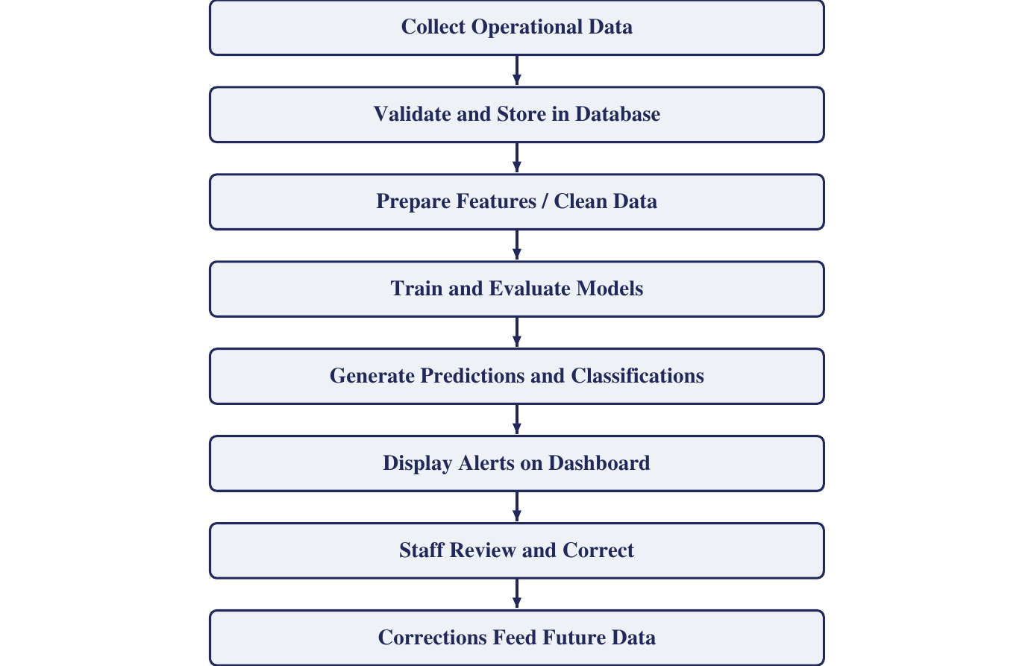
Figure 4.3: Intelligence and Analytics Workflow

Optional Advanced Components: An AI hostel assistant, a digital hostel simulation and CCTV integration are advanced or optional components, to be attempted only after the core and intelligence modules are in place. The assistant is a natural-language interface connected to authorized backend functions, and RBAC must be enforced before any sensitive information or action is exposed. The simulation models situations such as increased intake, room closures, maintenance shutdowns and accommodation shortages to support planning.

4.4.4 Resident Services and Finance Module

This module handles the everyday services that residents use and the financial administration of the hostel.
Another important objective is to maintain the hostel account manager, which records income and expenditure and supports transparent financial management. The module also facilitates the booking of services such as Wi-Fi, gym facilities, fitness corners, and entertainment services. These features allow students to access hostel amenities conveniently and help administrators monitor their usage.
Furthermore, the module provides notifications and reminders regarding bookings, payment deadlines, and other important hostel activities. It also provides a public showcase link that can be integrated into the college website to display relevant hostel information. Overall, this module aims to improve resident services, simplify financial operations, reduce manual administrative work, and provide a convenient and organized hostel management experience.

Mess and Inventory Management: Meal bookings and consumption are recorded, and mess staff maintain kitchen inventory. These records feed the forecasting and food-waste analysis in Section 4.4.3.

Fees, Subscriptions and Payment Deadlines: Fees and subscription plans, such as Wi-Fi or gym access, are recorded with an amount and a due date. The system raises reminders as a deadline approaches and flags overdue payments. The administrator dashboard reports fee collection.

Hostel Account Manager: The account manager records income, such as fees and subscriptions, and expenditure, such as food supplies, maintenance and utilities, so that the administration has a transparent financial view. The balance for a period is:
Net balance = Total income - Total expenditure

Amenity and Fitness-Corner Booking: Residents can book slots for the gym, the entertainment area and the fitness corner. Each slot has a capacity, and a booking is accepted only when capacity remains:
Accept booking if Booked (slot) < Capacity (slot)

Notifications: The notification service sends reminders for payment deadlines, leave and movement approvals, complaint status, safety inspections and emergency alerts, through push or e-mail messages according to role.
Public Showcase Link: A public page or widget, linked from the college website, presents the hostel's services and facilities. It exposes only non-sensitive, public information and does not provide access to any resident data.
HostelOS integrates the residents, service, and finance modules into a single platform to simplify hostel management. The resident’s module manages student information and room allocation, the service module handles complaints, maintenance, and hostel facilities, and the finance module manages fees, payments, and financial records. Together, these modules reduce manual work, improve accuracy, increase transparency, and ensure efficient hostel operations.
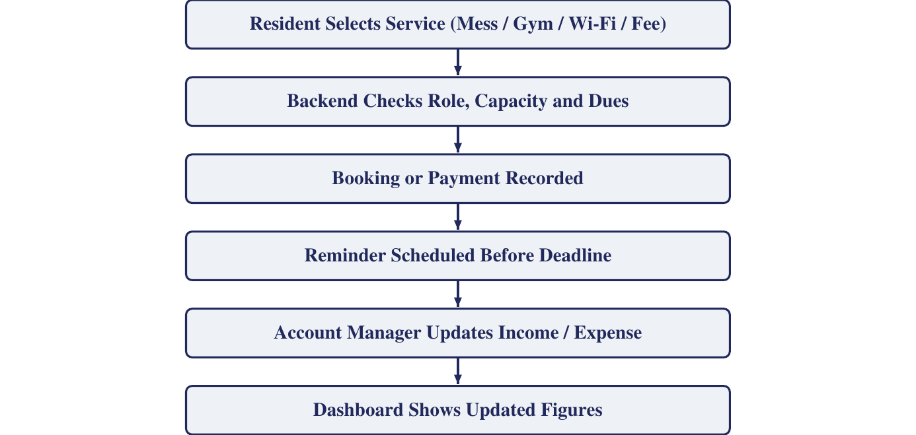
Figure 4.4: Resident Services and Finance Workflow

4.4.5 Module Allocation among Team Members

The modules are divided among the four team members so that each one's scope is self-contained and can be demonstrated independently. This is the proposed allocation; the final contribution record must reflect the work each member actually performs.

Team member | Register No. | Module
Gokul SR | BMC23CS056 | 4.4.1 Core Administration, Identity and Movement Authorization
Jeen George | BMC23CS057 | 4.4.2 Safety, Emergency and Gate Verification
S Adithyan | BMC23CS094 | 4.4.3 Intelligence and Analytics
Albi Thomas | LBMC23CS105 | 4.4.4 Resident Services and Finance
Table 4.3: Proposed Module Allocation

